CS 340 - DASHBOARD README

Project Overview
The purpose of this project was to develop a web-based dashboard application for Grazioso Salvare that allows users to interact with and visualize data stored in a MongoDB database. The dashboard was created using Python, MongoDB, and the Dash framework following the Model View Controller design pattern. The application enables users to filter rescue dog candidates based on specific rescue categories and view the results through an interactive data table and visual charts.
The dashboard includes the following required functionality:
- Grazioso Salvare logo
- Developer identification containing my name
- Interactive filtering options for:
  - Water Rescue
  - Mountain or Wilderness Rescue
  - Disaster Rescue or Individual Tracking
  - Reset (displaying all records)
- Interactive data table displaying Austin Animal Center records
- Geolocation map that updates dynamically based on selected filters
- Pie chart displaying breed distribution that updates dynamically based on selected filters

Screenshots
- Unfiltered Dashboard
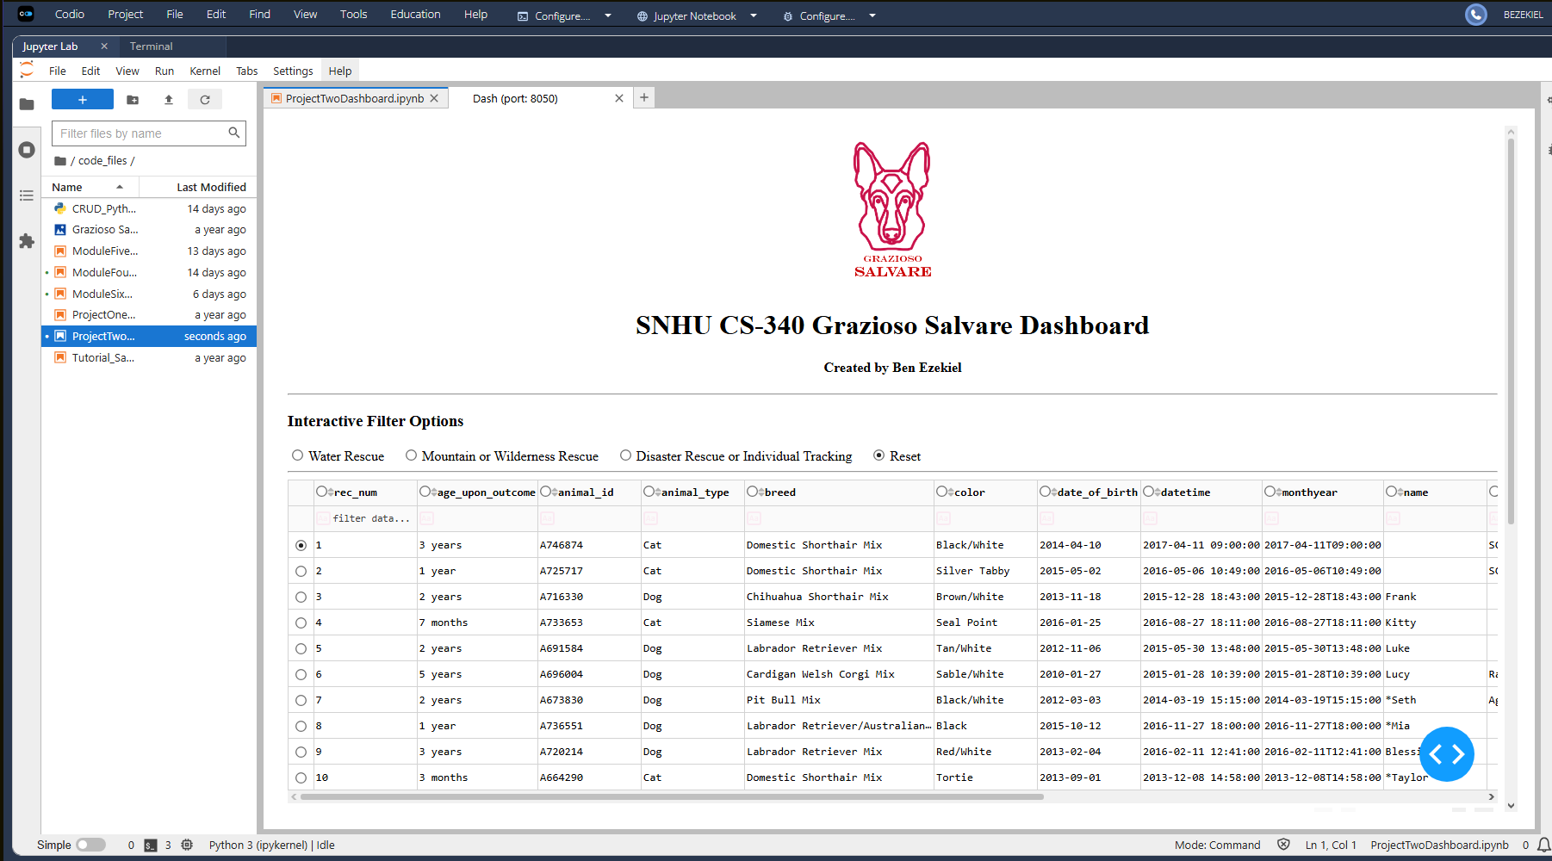
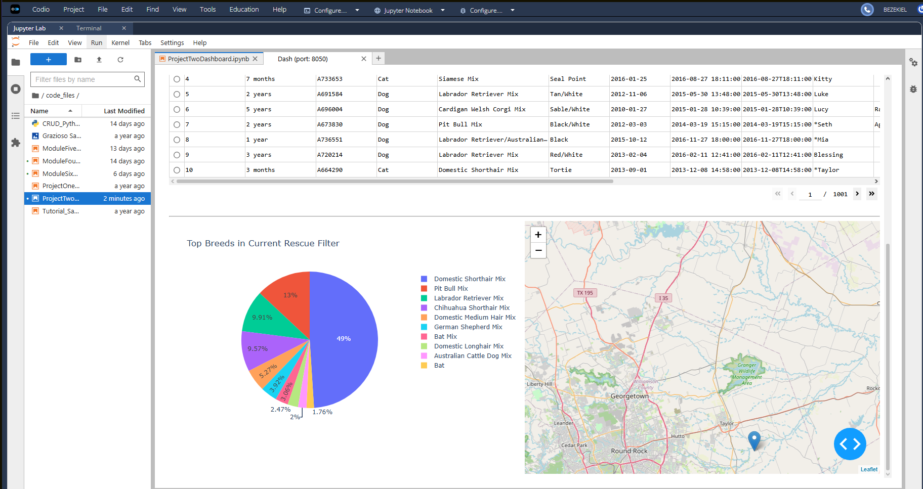
- Water Rescue Filter
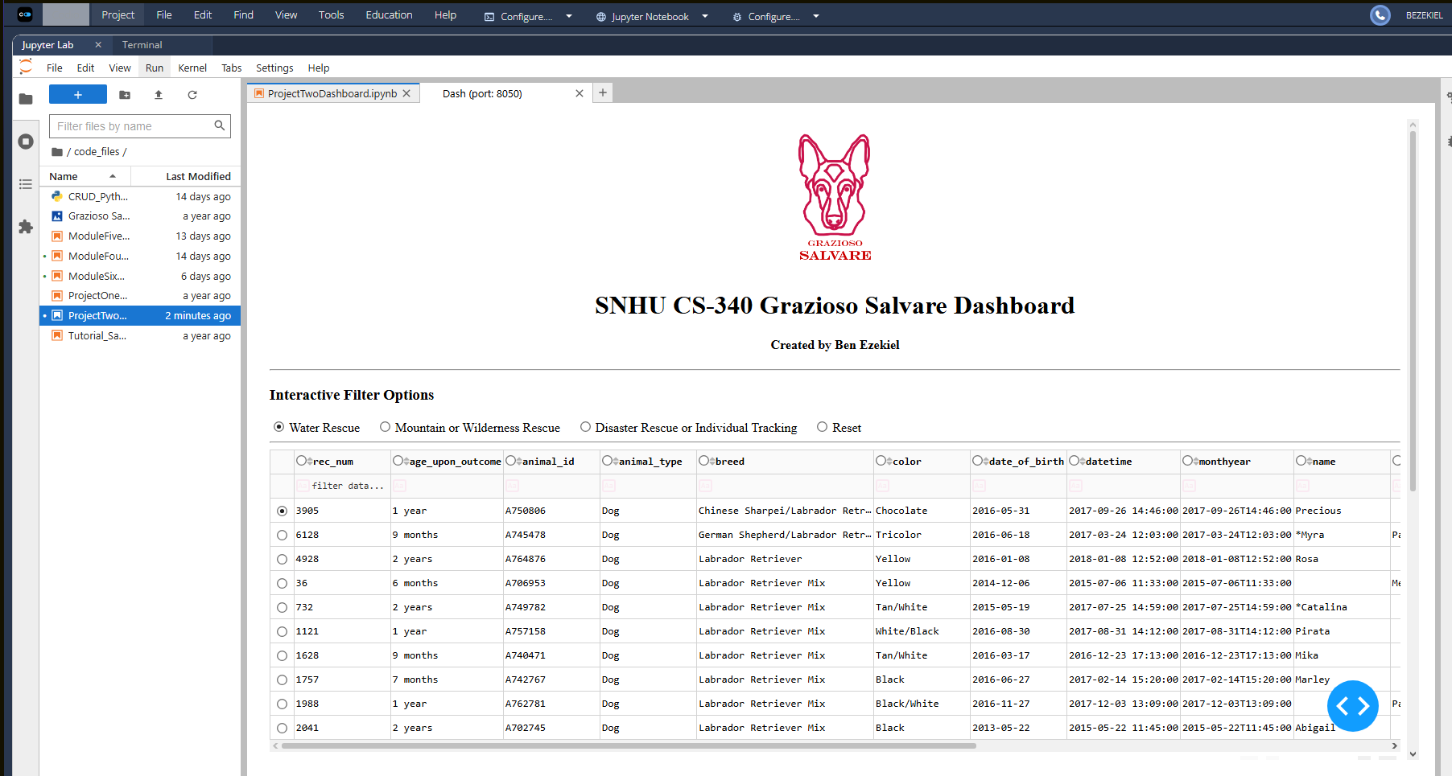
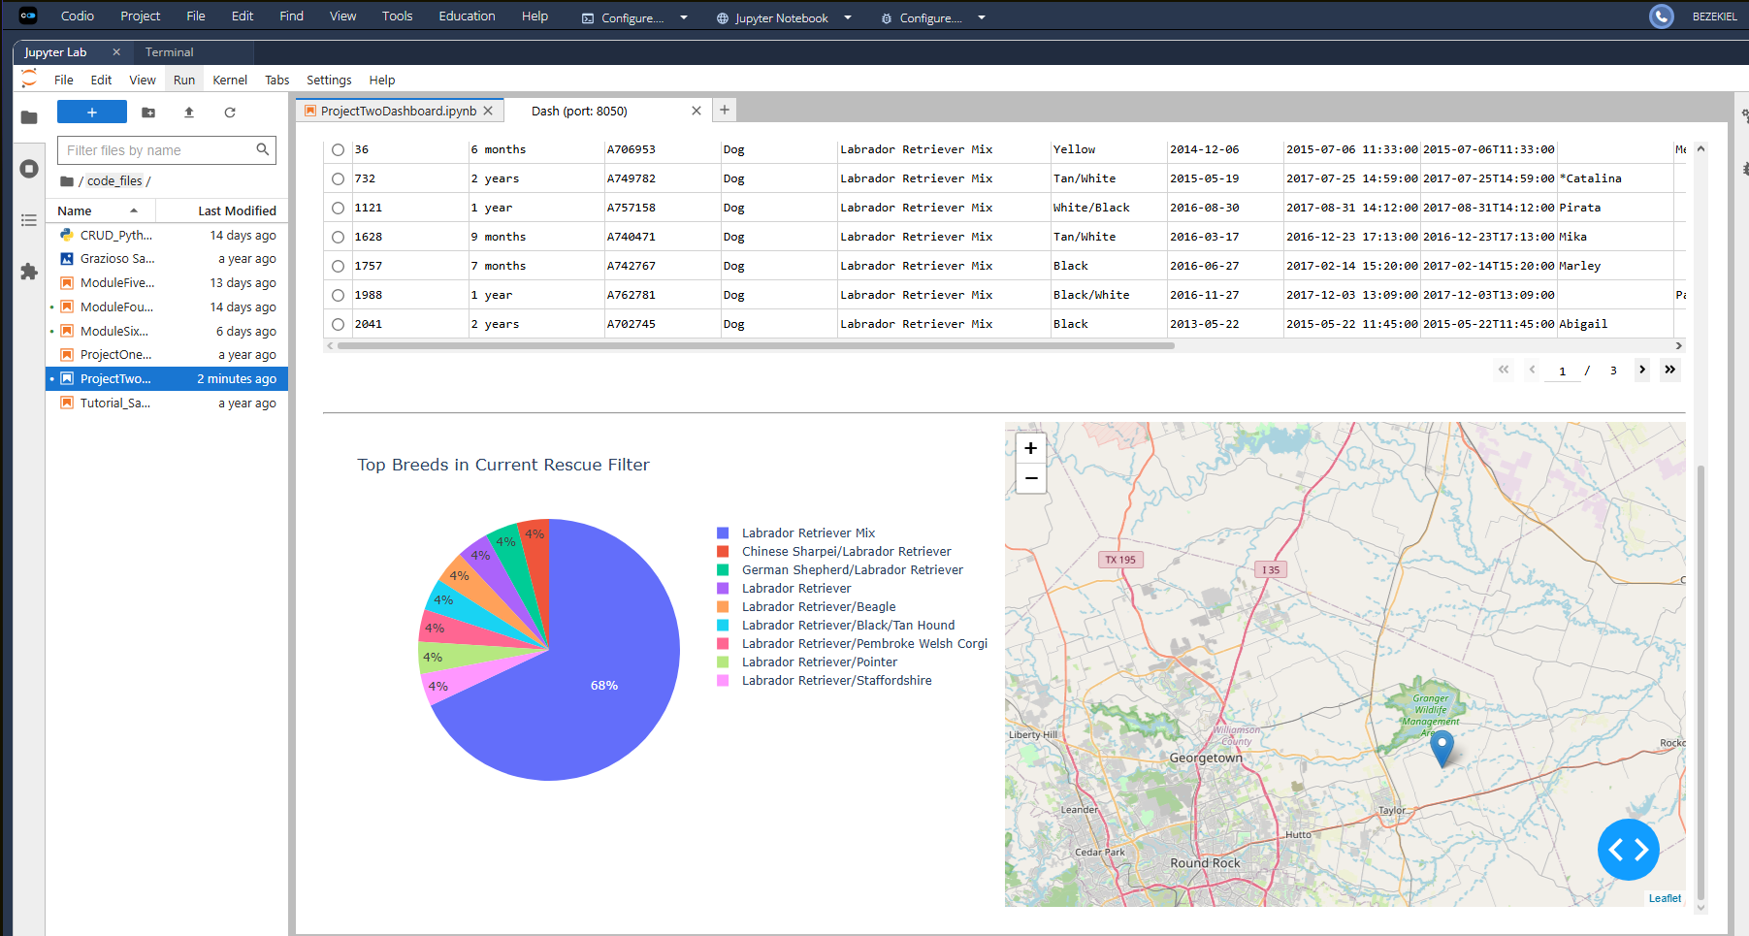
- Mountain or Wilderness Rescue Filter
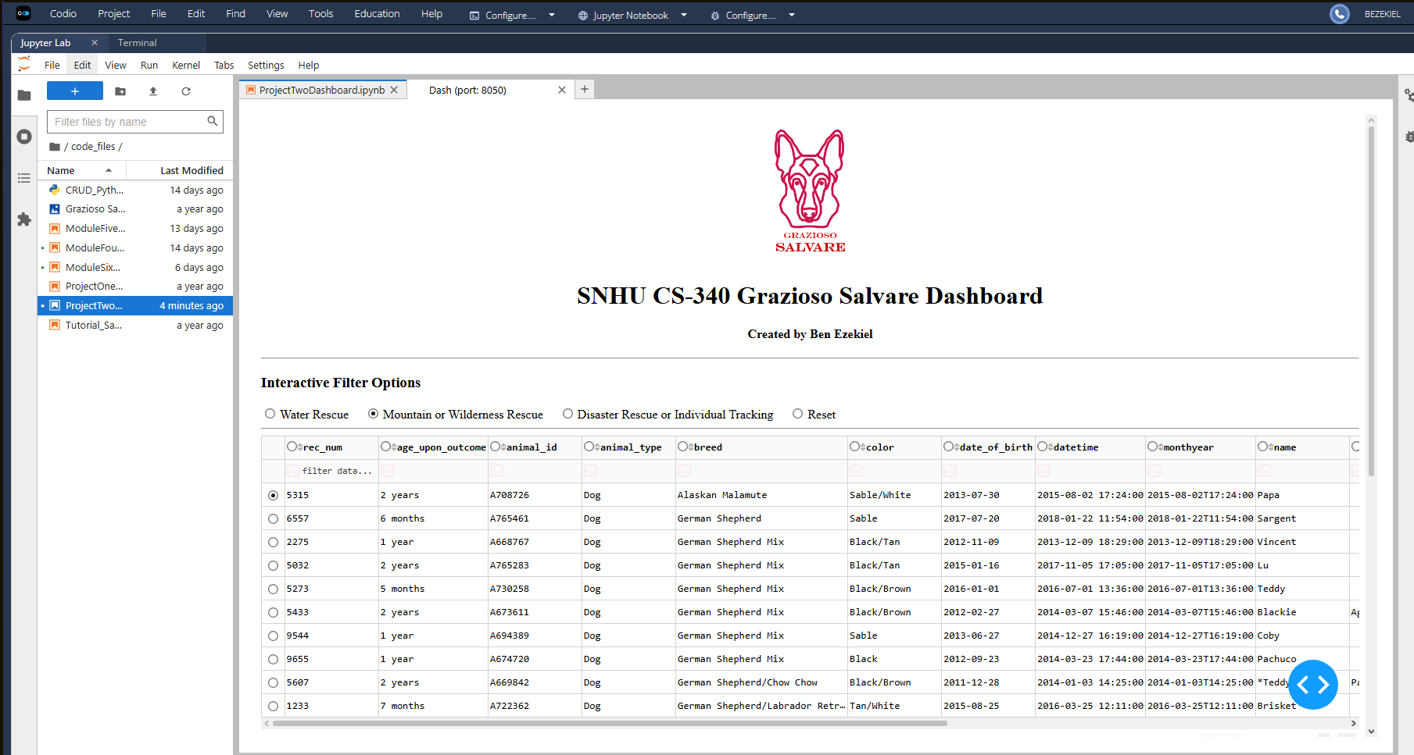
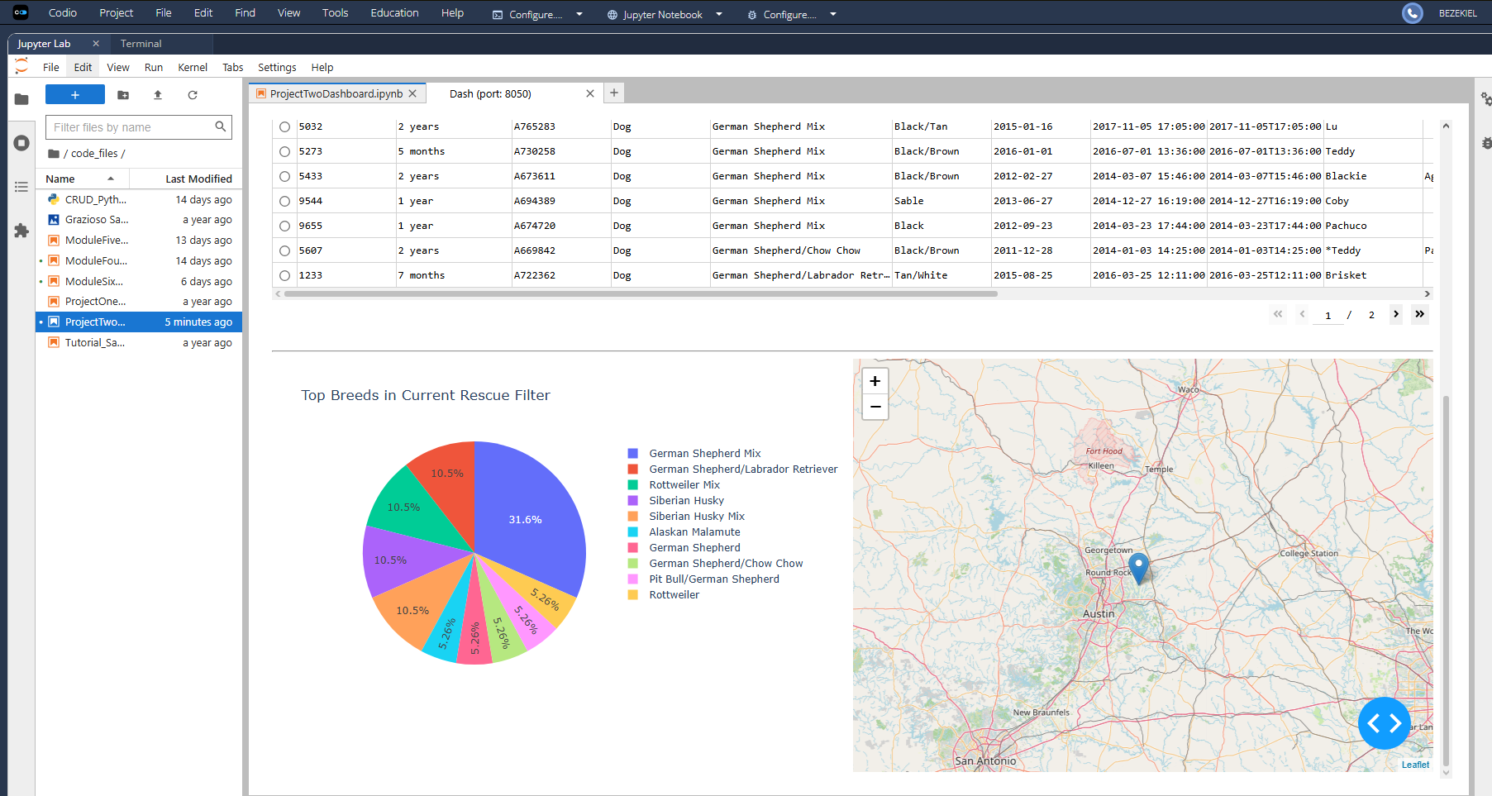
- Disaster Rescue or Individual Tracking Filter
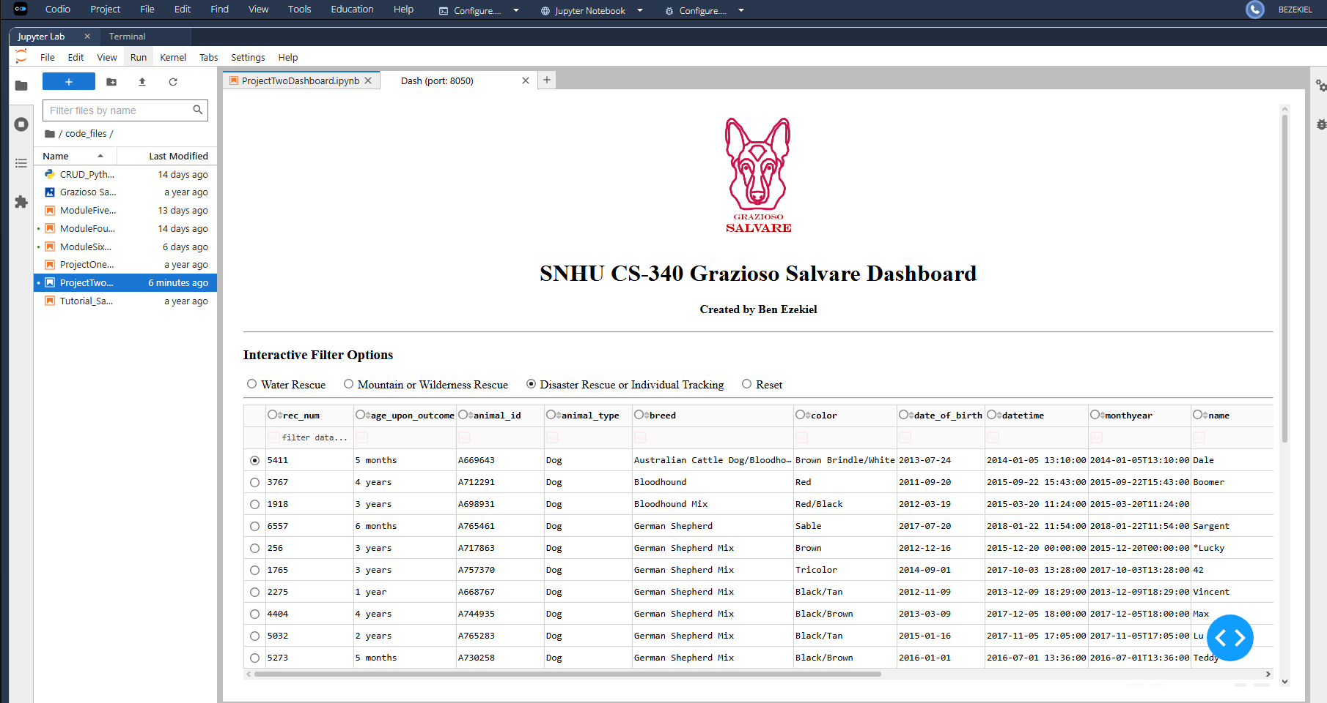
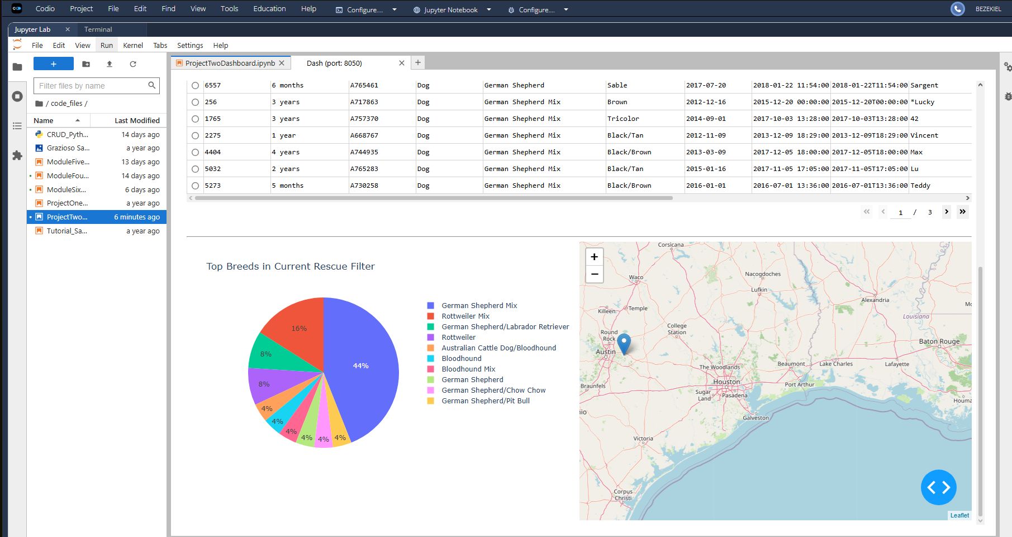

Tools and Technologies Used

Python
Python was used as the primary programming language because of its extensive support for database integration, data analysis, and web application development. Python also provides excellent support for MongoDB through the PyMongo library and integrates seamlessly with Dash.

MongoDB
MongoDB was selected as the database solution because it is a NoSQL document-oriented database that stores data in flexible JSON-like documents. This structure is ideal for working with animal shelter data because records can be stored and retrieved efficiently without requiring rigid relational schemas.
MongoDB also provides several advantages when working with Python:
- Native support for JSON-style documents
- Easy integration through the PyMongo library
- Flexible schema design
- Efficient querying and filtering of large datasets
- Ability to return query results directly into Python data structures
Within the MVC architecture, MongoDB serves as the Model component because it stores and manages all application data.

PyMongo
PyMongo was used to establish communication between Python and MongoDB. The CRUD module developed in Project One uses PyMongo to perform:
- Create operations
- Read operations
- Update operations
- Delete operations
The dashboard accesses MongoDB exclusively through this reusable CRUD module.

Dash Framework
Dash was used to build the web application interface. Dash is a Python framework developed by Plotly that allows developers to create interactive dashboards without requiring JavaScript.
Dash serves as both the View and Controller components of the MVC architecture.
View Components:
- Interactive data table
- Radio button filter controls
- Geolocation map
- Pie chart
- Dashboard branding elements
Controller Components:
- Callback functions
- User interaction handling
- Dynamic data filtering
- Chart updates
Dash was selected because it:
- Integrates directly with Python
- Supports interactive visualizations
- Provides reactive callback functionality
- Simplifies dashboard deployment
- Includes built-in support for Plotly charts

Plotly
Plotly was used to create:
- Interactive geolocation map
- Interactive pie chart
Plotly integrates directly with Dash and allows charts to update automatically when users select different filters.

Project Development Process

Step 1: Create CRUD Module
Developed a reusable Python CRUD module capable of:
- Creating records
- Reading records
- Updating records
- Deleting records
The module was configured to connect to:
Database:
- aac
Collection:
- animals
Credentials:
- Username: aacuser
- Password: stallions

Step 2: Build Initial Dashboard
Created the dashboard layout using Dash components:
- Header section
- Grazioso Salvare logo
- Developer identification
- Interactive data table
The data table was populated using records retrieved through the CRUD module.

Step 3: Create Database Queries
Developed MongoDB queries corresponding to the rescue categories defined in the Dashboard Specifications Document:

Water Rescue
- Labrador Retriever Mix
- Chesapeake Bay Retriever
- Newfoundland
- Intact Female
- Age between 26 and 156 weeks

Mountain or Wilderness Rescue
- German Shepherd
- Alaskan Malamute
- Old English Sheepdog
- Siberian Husky
- Rottweiler
- Intact Male
- Age between 26 and 156 weeks

Disaster Rescue or Individual Tracking
- Doberman Pinscher
- German Shepherd
- Golden Retriever
- Bloodhound
- Rottweiler
- Intact Male
- Age between 20 and 300 weeks

Step 4: Implement Interactive Filters
Created radio button controls allowing users to select:
- Water Rescue
- Mountain Rescue
- Disaster Rescue
- Reset
Dash callback functions were implemented to process user selections and execute the appropriate database queries.

Step 5: Create Dynamic Visualizations
Added:
- Interactive geolocation map
- Interactive pie chart
Both visualizations update automatically whenever a user selects a different rescue filter.

Step 6: Test and Deploy Dashboard
Tested all dashboard functionality including:
- Database connectivity
- CRUD operations
- Filter selections
- Data table updates
- Map updates
- Pie chart updates
- Reset functionality

Challenges Encountered

CRUD Integration
One challenge involved connecting the dashboard to the CRUD module while maintaining reusable code. This issue was resolved by importing the CRUD class directly into the dashboard application and using it for all database interactions.

MongoDB Query Development
Constructing rescue-specific queries required careful interpretation of the Dashboard Specifications Document. Breed, age, and sex requirements needed to be combined correctly using MongoDB query operators. Testing each query independently ensured accurate filtering.

Dynamic Dashboard Updates
Creating synchronized updates between the radio buttons, data table, map, and pie chart required a thorough understanding of Dash callback functions. This challenge was overcome by using callback inputs and outputs to ensure all components refreshed whenever a filter selection changed.

Geolocation Visualization
Ensuring that the geolocation map displayed the correct animal location information required proper formatting of latitude and longitude data. This was resolved through data validation and testing with filtered records.

Contact
Ben Ezekiel
CS 340 – Client/Server Development
Southern New Hampshire University

